LG VideoChat

Phase 2

Team 3

Contents

1. Introduction 3

2. Project Members and Role 4

3. Schedule 5

4. Attack Tree 5

5. Executive Summary 7

6. Evaluation Constraints 8

7. Evaluation Narrative 9

8. Vulnerability Reporting 10

9. Conclusions and Recommendations 11

# 1. Introduction

This report presents a comprehensive overview of the security assessment phase2.

We are going to evaluate the team1’ artifact. Through,, start from the analysis of the architect , design attack plan and execute real attack and finally conclusions.

# 2. Project Members and Role

Server vulnerability analysis – Seongjun Kim, Seki Park

Client vulnerability analysis – Sungmin Kim, Donghoon Shin

Static analysis and fuzzing - Jiyoung Yoon

Mentor – David Belasco

# 3. Schedule

Here's a brief summary of phase 2 schedule.   
Over the course of 2 weeks, we focused on different aspects of our project. The first week was dedicated to analysis and brainstorm for making attach tree.

In the second week, we worked on real attacks and conclusions.

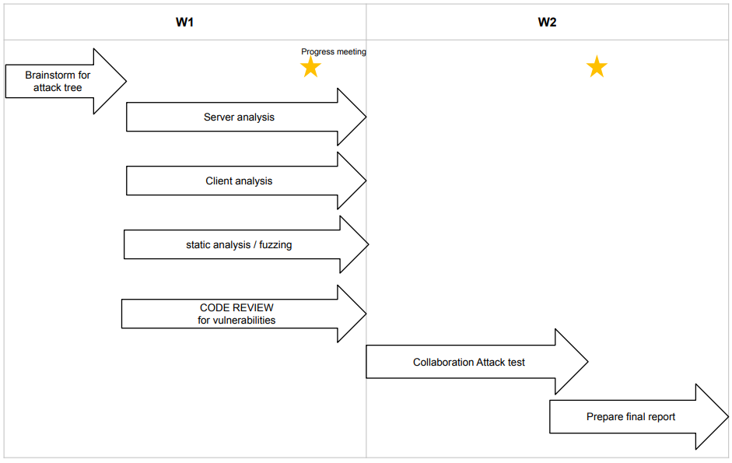

# 4. System Information

## 1. System Architecture

2

call CALL_STATUS_PORT :10002

VOIP_LOCAL_PORT :10001

VIDEO_PORT :10000

## 2. Port Information

The open port was checked using code review and nmap tool.

call CALL_STATUS_PORT :10002

VOIP_LOCAL_PORT :10001

VIDEO_PORT :10000

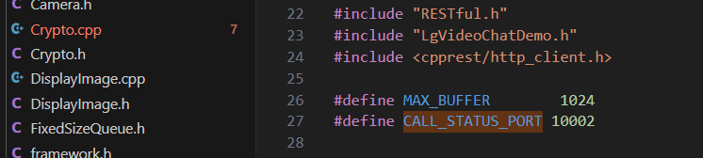

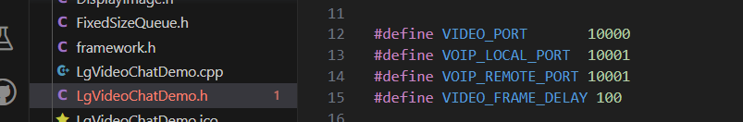

## 3. HTTPS

A login requirement document and code review confirmed that the client and server use https for communication. Also, it was confirmed using packet dump using the Wireshark tool.

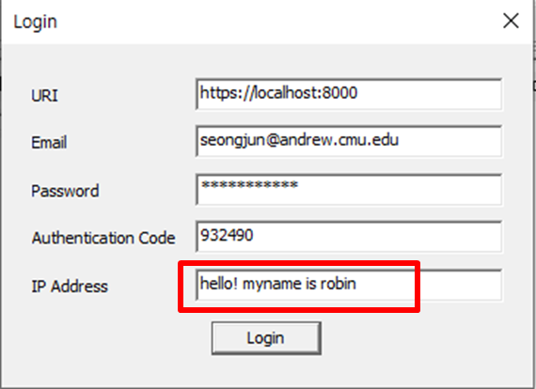

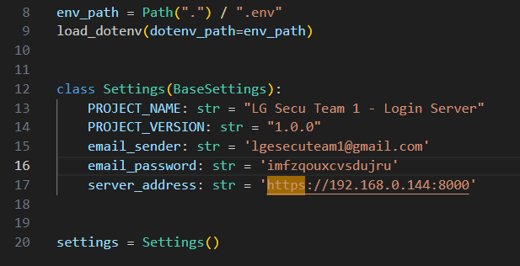

## 4. Video/audio Encryption/ Decryption

Video/audio data is encrypted using the AES Key generated by the Voip server and then transmitted.

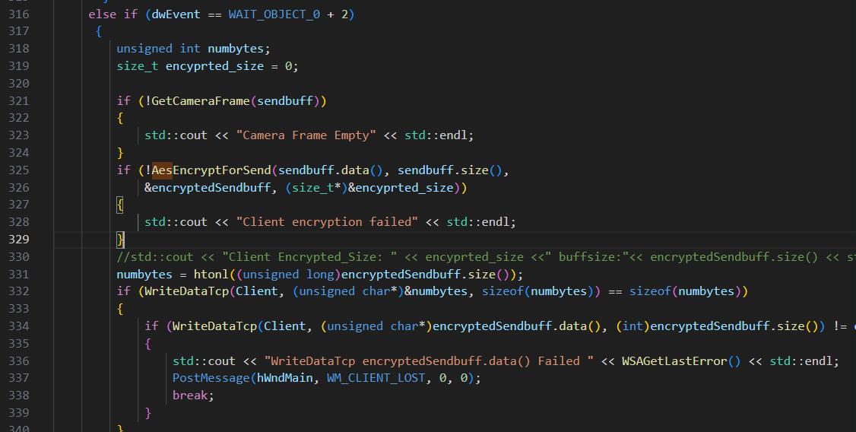

# 5. Attack Tree

We design the attack tree below to find attack point.

We have identified one potential threat as the creation of an abnormal video call state. To effectively manage this threat, we have categorized the necessary actions required to address and mitigate its potential impact on our system.

The sections highlighted in yellow represent areas where Team 3 successfully executed an attack. However, due to the application of our security mitigations, the remaining attack attempts were unsuccessful. This underlines the effectiveness of our preventative measures in maintaining the security and integrity of our system.

Our first successful attack was achieved by making a fake call. We obtained a public_key and a hash_id through an opened signal port and transferred encrypted data. This enabled us to imitate another person making a call.

Secondly, we succeeded in performing an attack through denial of service by executing fake calls infinitely. The constant pop-ups hindered the use of the video call functionality.

Thirdly, we observed that the video port was always open before a call connection, allowing us to send arbitrary data to the video port. This resulted in an interruption of the video call, simulating the effect of a successful attack. When repeated indefinitely, this activity resulted in a denial of service.

Lastly, we identified a deficiency in the input validation of the video call feature. Entering an incorrect IP address into the video chat program made it possible to insert invalid strings, underscoring the vulnerability of the system.

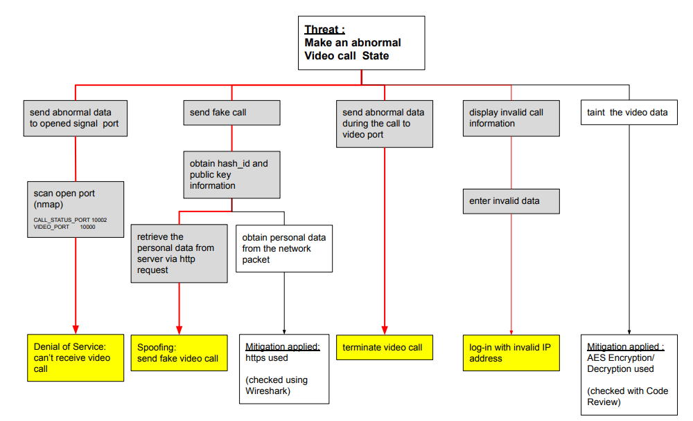

# 6. Executive Summary

Major 5 vulnerability are below.

In the Executive Summary for Phase 2, which can be considered the main part of our project, we have identified the top 5 major vulnerabilities. These include issues related to Spoofing, Denial of Service, Information Disclosure, and Input Validation. Each of these vulnerabilities has been evaluated using the Common Vulnerability Scoring System (CVSS) (Appendix-22), and they are listed in the table below in descending order based on their respective scores. Furthermore, we have included our recommendations for mitigating these vulnerabilities within the same table.

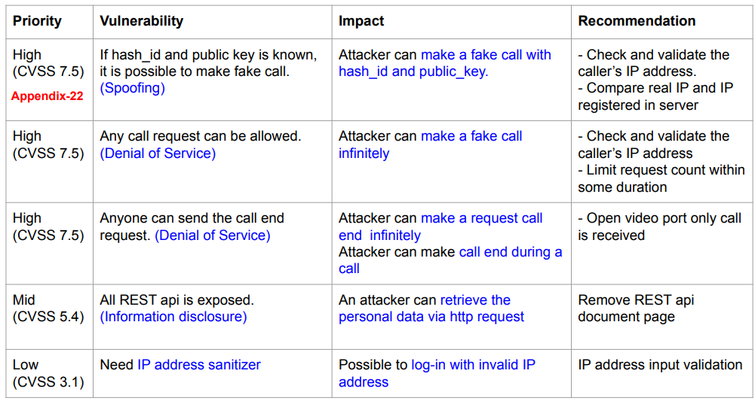

# 7. Evaluation Constraints

We assume below constraints for evaluation.

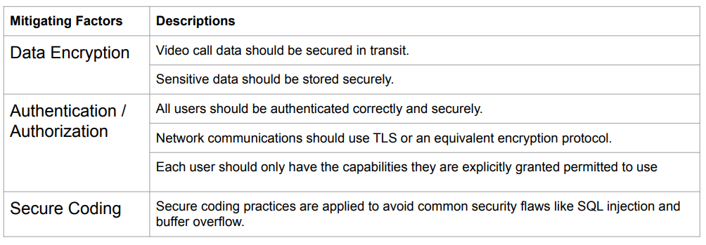

# 8. Evaluation Narrative

One of the key aspects of Phase 2 involves the evaluation carried out by Team 3, which is narratively described. In this context, an "X" denotes that a task was carried out, but did not contribute to identifying a vulnerability, while an "O" signifies that the task led to the discovery of a vulnerability, resulting in a successful attack. Although some tasks did not lead to successful attacks, they provided valuable learning opportunities in the realm of security.

We have detailed the tools used in our analysis and listed their respective results, assigning a unique vulnerability number to each identified threat. Additionally, screenshots of our analysis results are provided for further clarity in Appendix.

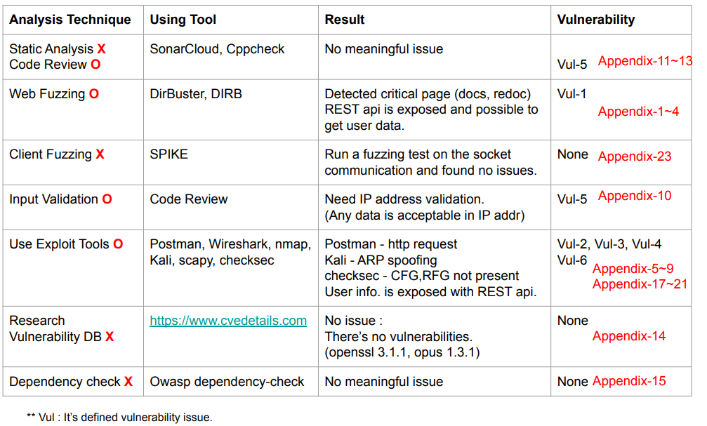

# 9. Vulnerability Reporting

The following section details the vulnerabilities we discovered during our assessment, each assigned a unique identification number for clarity and reference within our report.

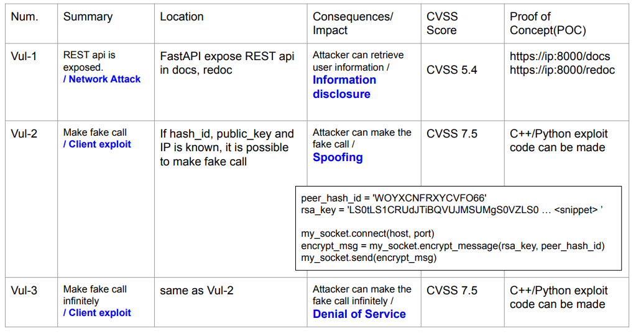

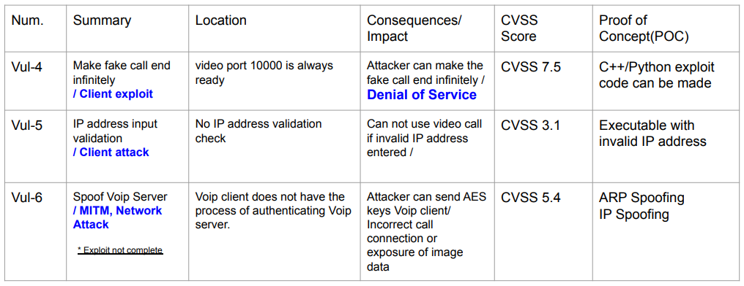

## VU-1 Information Disclosure(Postman) -Server Exploit

Step 1) The web fuzzing tool was used to gather the REST API information of the SSL Server.

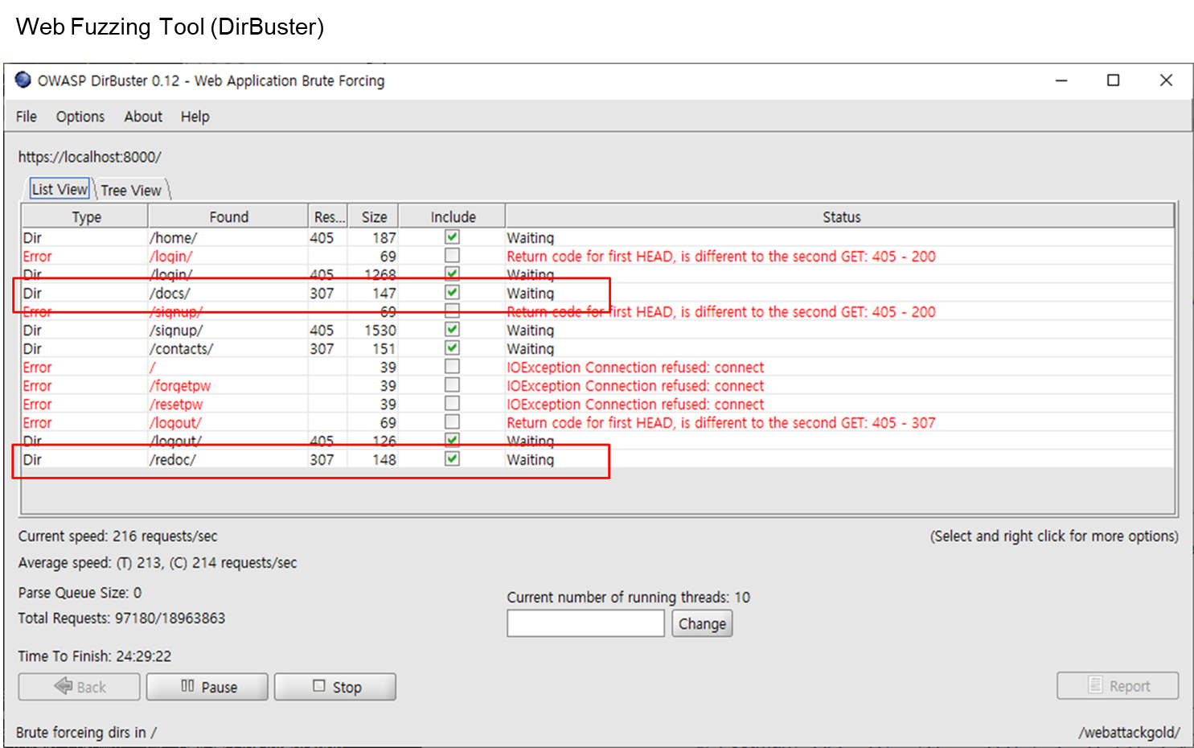

Step 2) Using url information and Postman Tool, we could check the information of the registered user from the server

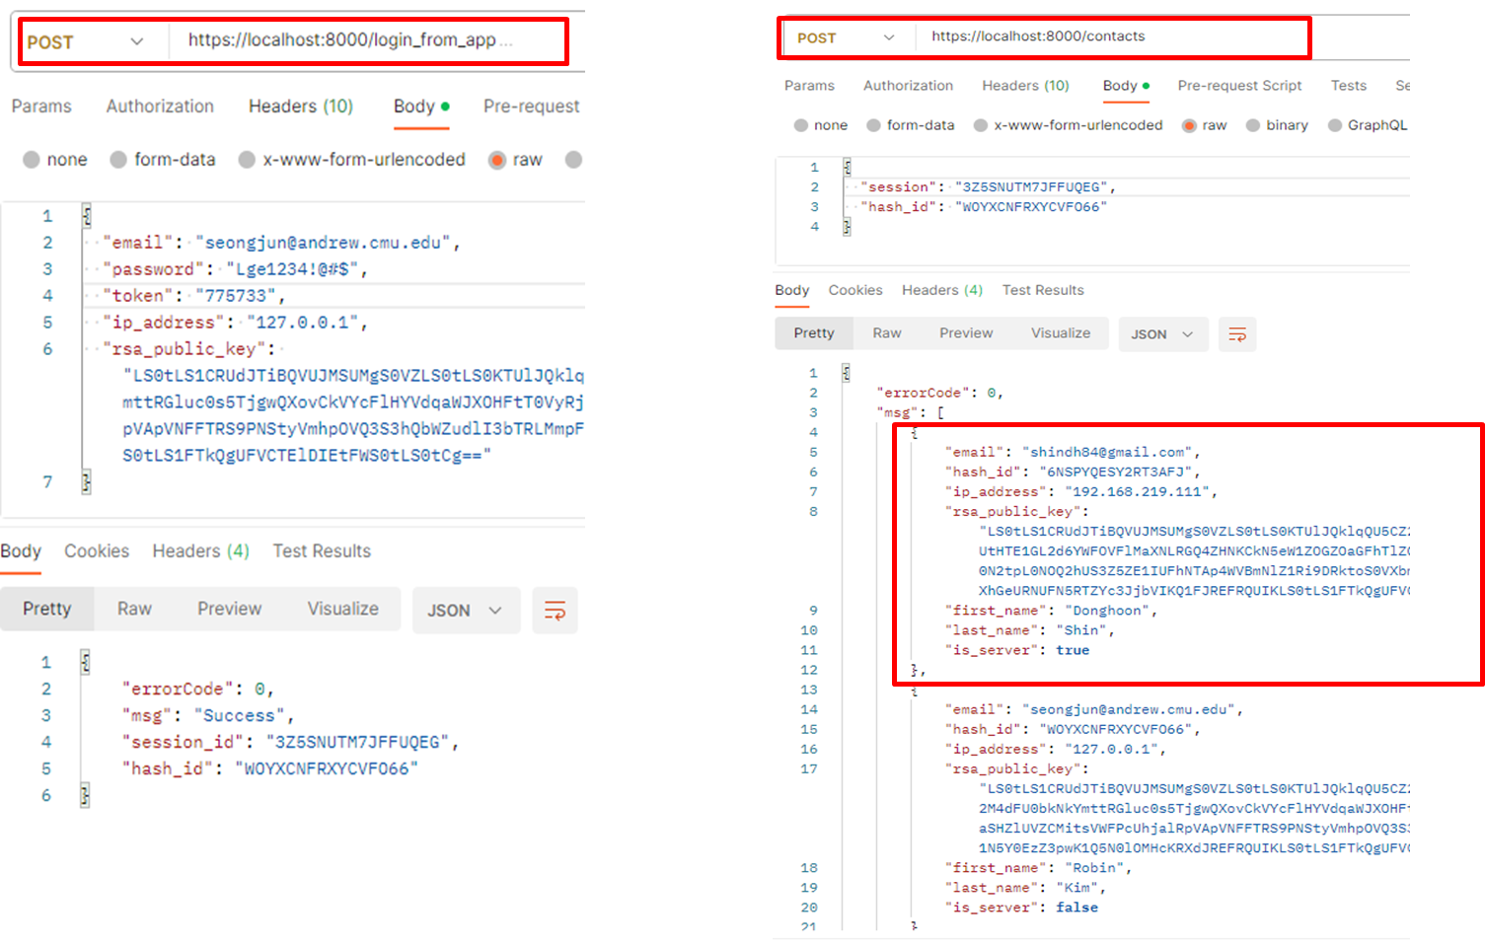

## Vu-2 Make fake call - Client Exploit

We can pretend to be someone else on the contact list with hash_id

and rsa_public_key and make a call

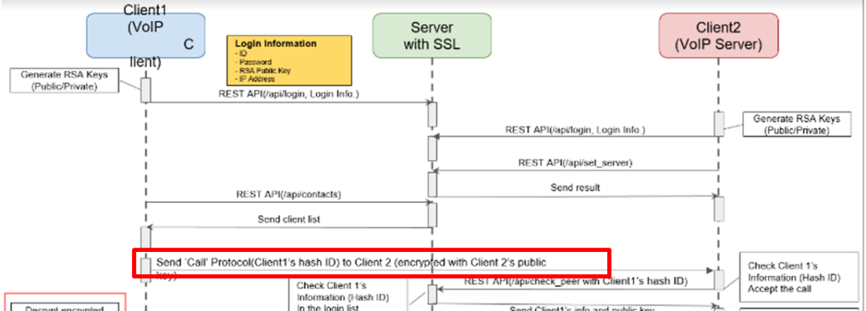

Exploit with hash_id and rsa_public_key for making a call

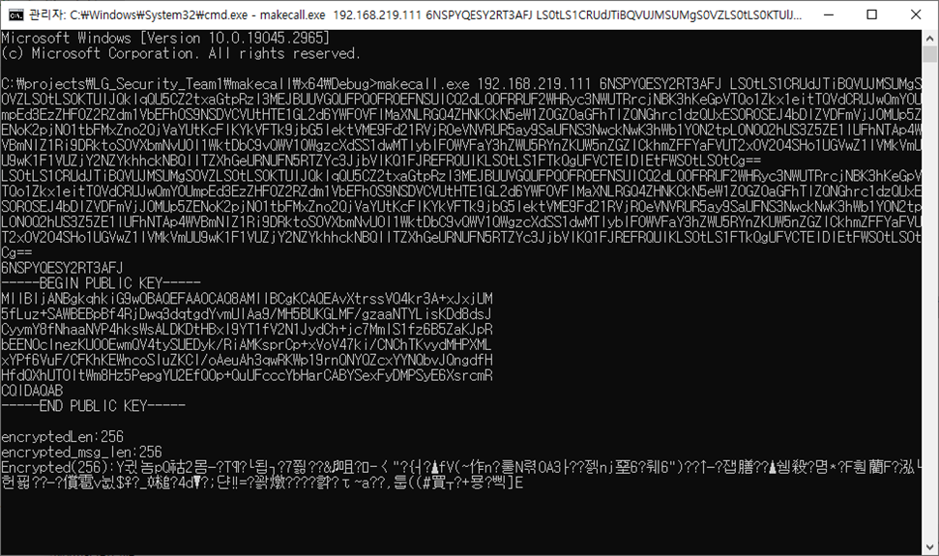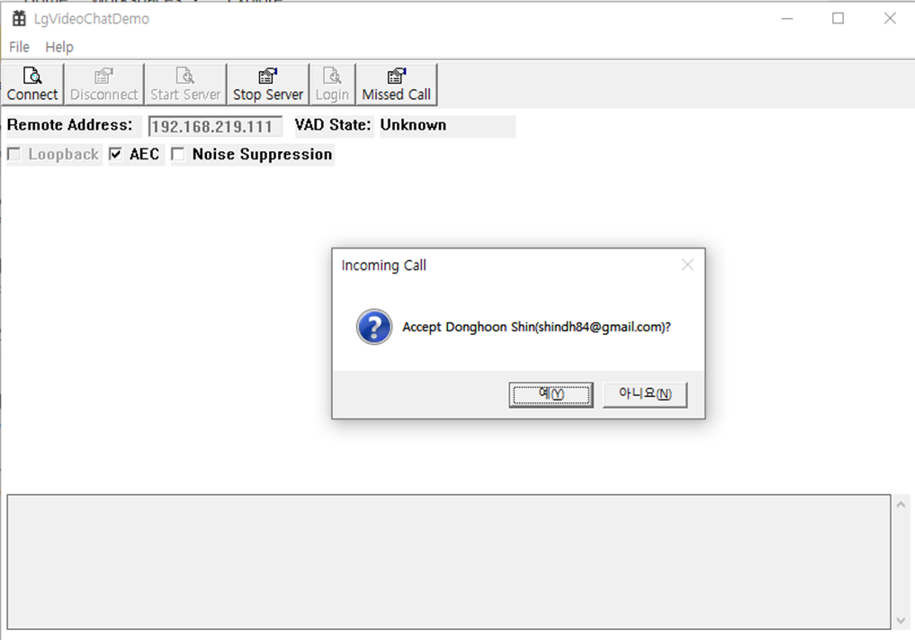

## Vul-3 Make fake call infinitely - Client Exploit

Exploit with hash_id and rsa_public_key for making a call Last option is count and if we keep make a call, app invoke notice popup infinitely

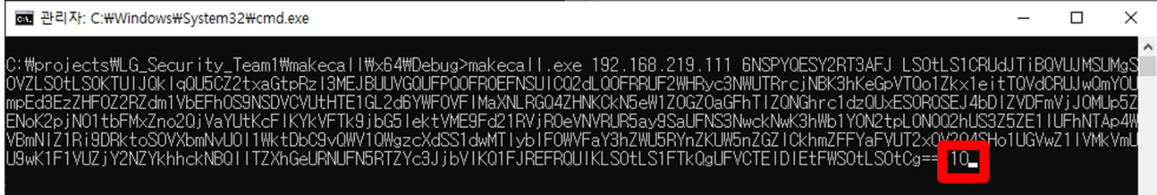

## Vul-4 Make fake call end infinitely - Client Exploit

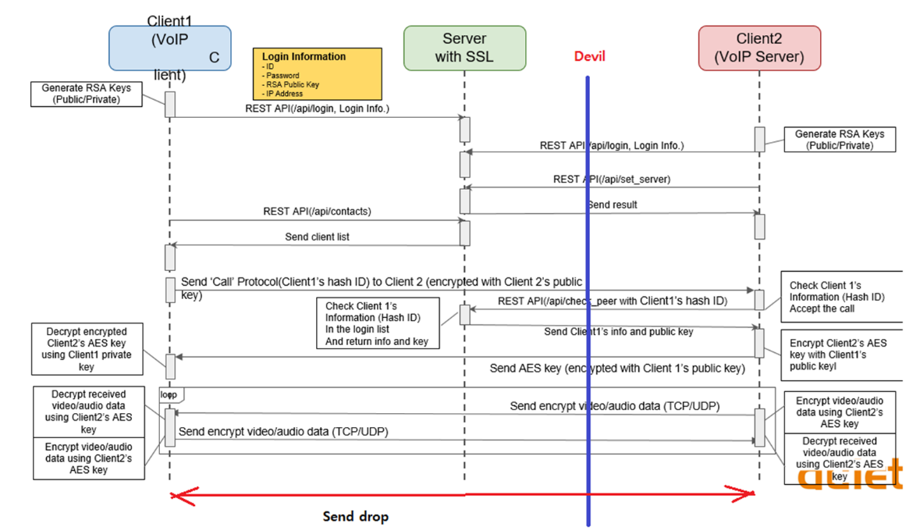

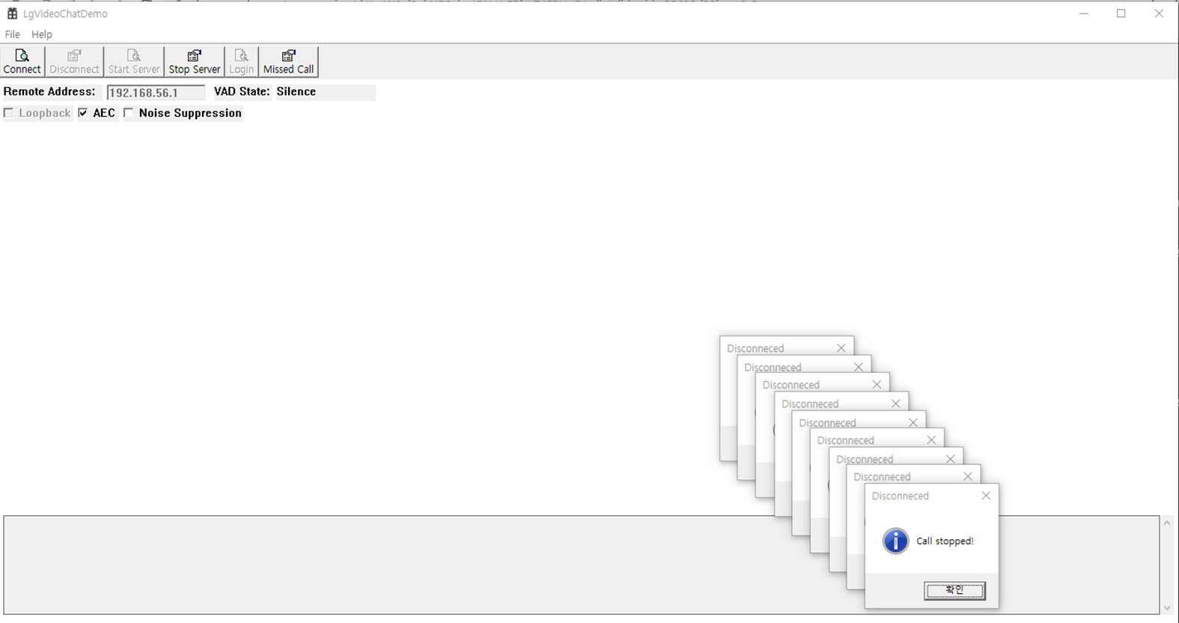

## Vul-5 IP address input validation - Client Attack

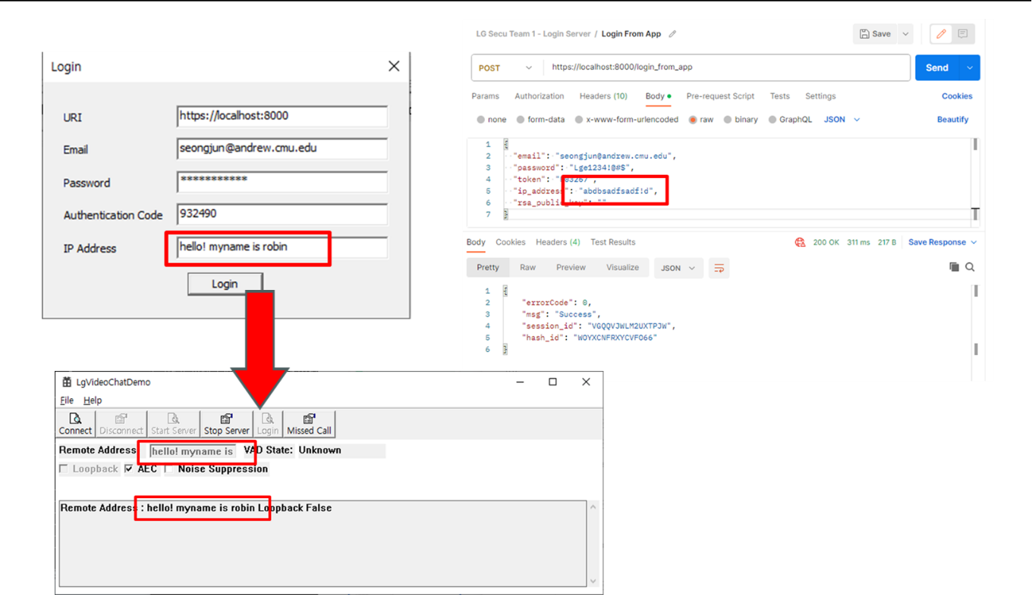

## Vul-6 Spoof Voip Server - MITM, Network Attack (* Exploit not complete)

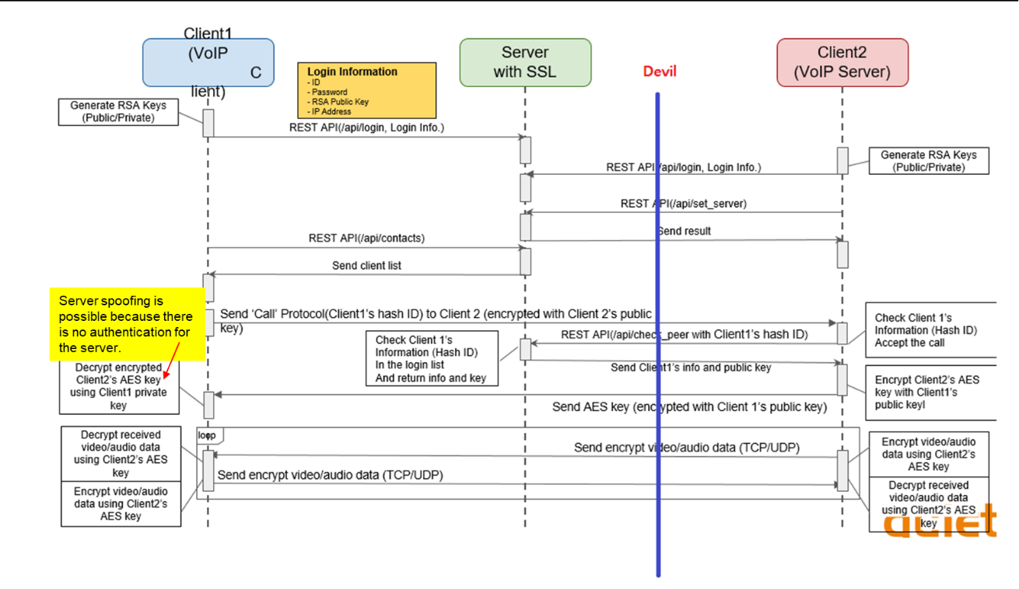

Server spoofing is possible because there is no authentication for the server.

ARP spoofing was successful using kali linux, and packets were captured using wireshark.

However, I could not receive a call after impersonating the server.

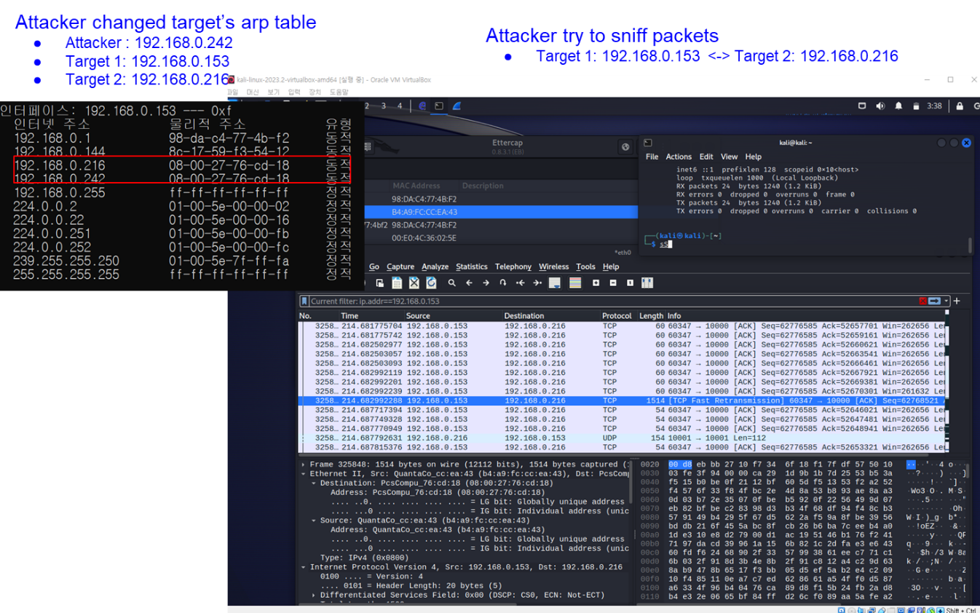

# 10. Conclusions and Recommendations

In conclusion, the following items represent the vulnerabilities discovered by Team 3 during our evaluation. Alongside each vulnerability, we've included our recommendations for mitigating these risks.

